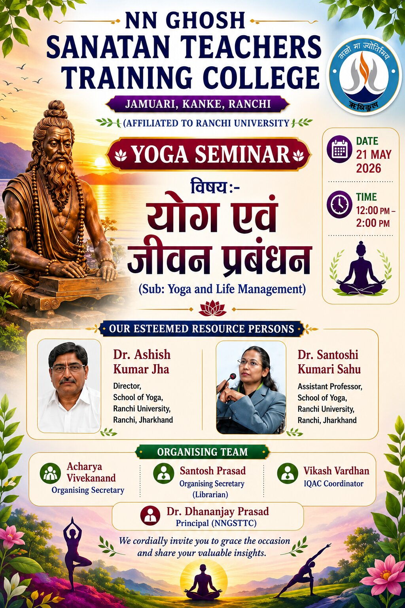
Report on Yoga Seminar
NN Ghosh Sanatan Teachers Training College, Jamuari, Kanke, Ranchi

A Yoga Seminar on the topic “Yoga and Life Management” was successfully organized on 21 May 2026 at NN Ghosh Sanatan Teachers Training College, Jamuari, Kanke, Ranchi. The seminar was conducted from 12:00 PM to 2:00 PM with the objective of creating awareness about the importance of yoga in maintaining physical, mental, and emotional well-being.
The programme began with a warm welcome of the guests and participants. Prof. (Dr.) Bijay Singh, Director General, Sanatan Group of Education, delivered the inaugural speech. In his address, he highlighted the significance of yoga in daily life and emphasized its role in achieving discipline, concentration, and a healthy lifestyle.
The Principal, Dr. Dhananjay Prasad, also participated in the seminar and encouraged students and faculty members to adopt yoga as a regular practice for holistic development.
The seminar featured esteemed resource persons including Dr. Ashish Kumar Jha(chief guest), Director, School of Yoga, Ranchi University, and Dr. Santoshi Kumari Sahu, Assistant Professor, School of Yoga, Ranchi University. Both speakers shared valuable insights on yoga practices, stress management, meditation, and life management techniques.
The programme was efficiently anchored by Vikas Vardhan. The organizing team included Acharya Vivekanand, Santosh Prasad (Librarian), and Vikas Vardhan, whose dedicated efforts contributed to the successful execution of the seminar.
At the end of the programme, the Vote of Thanks was delivered by Acharya Vivekanand. He expressed gratitude to the chief guests, resource persons, faculty members, students, and organizers for their active participation and support.
The seminar concluded on a positive note with enthusiastic participation from students and faculty members. The event proved to be informative, inspiring, and beneficial for all attendees. Archana kumari and Smita dung dung provided great support in organizing the event .

