N.N. GHOSH SANATAN TEACHER TRAINING COLLEGE
Jamuari, Jharkhand
REPORT ON NATIONAL UNITY DAY CELEBRATION – 31 OCTOBER 2026

Event Details
Event | National Unity Day (Rashtriya Ekta Diwas) – Pledge-Taking Ceremony
Organised by | N.N. Ghosh Sanatan Teacher Training College, Jamuari, Jharkhand
Date | Saturday, 31 October 2026
Time | Approximately 2:45 PM – 2:50 PM (IST)
Venue | Conference hall, N.N. Ghosh Sanatan Teacher Training College, Jamuari
Presided by | Dr. Dhananjay Prasad, Principal
Participants | Teaching staff, non-teaching staff and students

1. Introduction
National Unity Day (Rashtriya Ekta Diwas) was observed at N.N. Ghosh Sanatan Teacher Training College on Saturday, 31 October 2026. A pledge-taking ceremony was organised on the occasion, in which teaching staff, non-teaching staff and students came together to reaffirm their commitment to the unity and integrity of the nation.

2. Significance of the Day
31 October marks the birth anniversary of Sardar Vallabhbhai Patel, the first Deputy Prime Minister and Home Minister of independent India, who is remembered for his role in bringing the princely states together into a single, united nation. India observes this day as National Unity Day to honour his contribution and to remind every citizen of the importance of unity, harmony and national integrity.

3. Proceedings of the Programme
The programme was held under the guidance of the Principal, Dr. Dhananjay Prasad. The ceremony began with the Principal addressing the gathering. He spoke about the importance of National Unity Day, the ideals of Sardar Vallabhbhai Patel, and the value of unity in a diverse country like India. He urged everyone to carry the spirit of unity into their personal and professional lives, especially as teachers and future teachers who shape young minds.
After the address, the Principal administered the National Unity Day pledge. All those present stood with their right hand extended and took the pledge together, resolving to preserve and strengthen the unity, integrity and security of the nation. A specially designed National Unity Day poster, carrying the message "Let us pledge to build a united and stronger India" and the theme "Unity in Diversity, Strength in Unity", was displayed on the screen in the hall during the ceremony.

4. Participation
The pledge-taking ceremony was attended by the teaching faculty, non-teaching staff and students of the college. The participants took part with discipline and enthusiasm, and the programme concluded in an atmosphere of patriotism and togetherness.

5. Conclusion
The programme reminded all members of the college community of the shared responsibility to uphold national unity. The college reaffirms its commitment to nurturing values of harmony, discipline and love for the nation among its student-teachers. The Principal thanked all staff members and students for their active participation and cooperation.
Dr. Dhananjay Prasad
Principal
N.N. Ghosh Sanatan Teacher Training College

Photographs of the Event
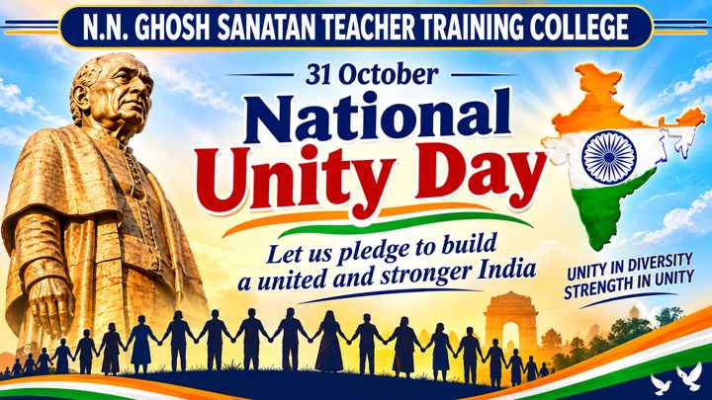
National Unity Day poster displayed during the programme
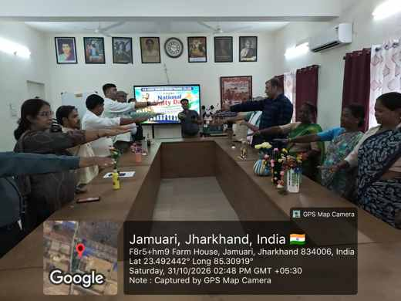  Staff taking the pledge (2:48 PM) | 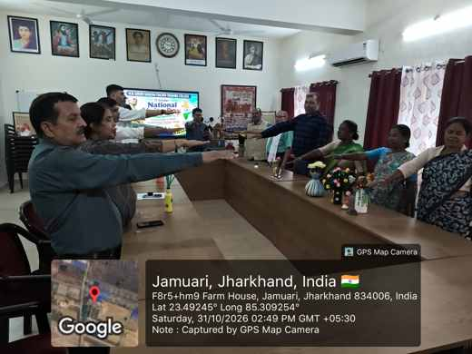  Pledge being taken in the hall (2:49 PM)
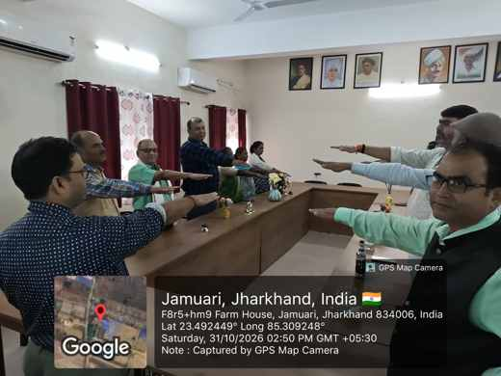  Participants during the pledge (2:50 PM) | 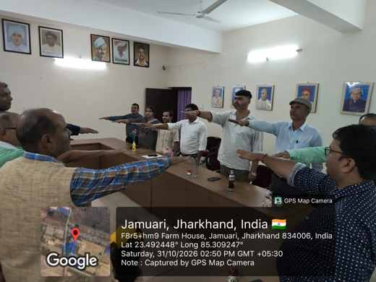  Group view of the pledge-taking (2:50 PM)

